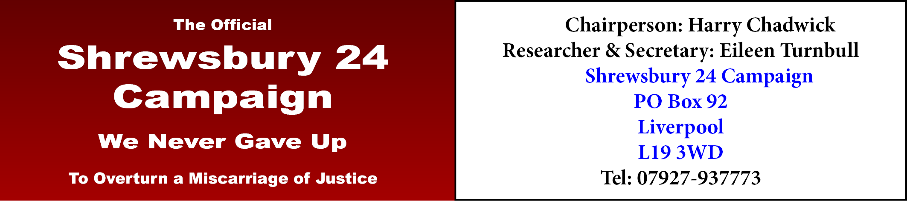

Please send me the following (prices include p&p, UK & Ireland only. For all other countries, prices on application):

….... copies of The Key to My Cell @ £4 each: .………….

….... copies of The Shrewsbury Three @ £3 each: ..…………

Total: ………….

Name ………………….…………………………..……………..…..
Address……………………………………………..…………….….
.……………………………………………………………..…………
………………………………………………………………………...
E-mail address.………………………………………………..……..
Telephone number…….……………………………………………..
Please make cheques payable to “Shrewsbury 24 Campaign”.
BACS payments can be made to the Shrewsbury 24 Campaign Co-op account number : 65249495 Sort code: 08-92-99
Send to: Eileen Turnbull, Secretary, Shrewsbury 24 Campaign, PO Box 92, Liverpool L19 3WD. Telephone: 07927-937773

